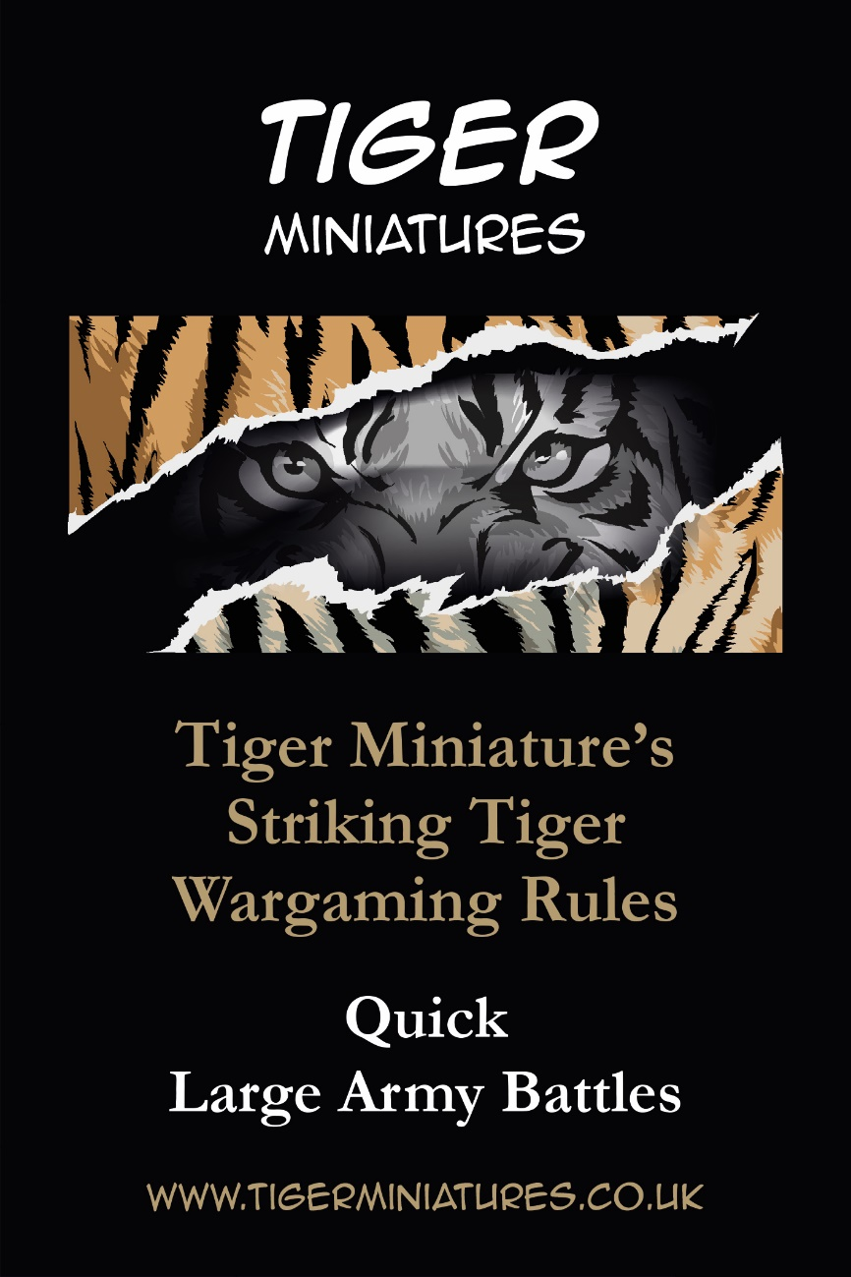

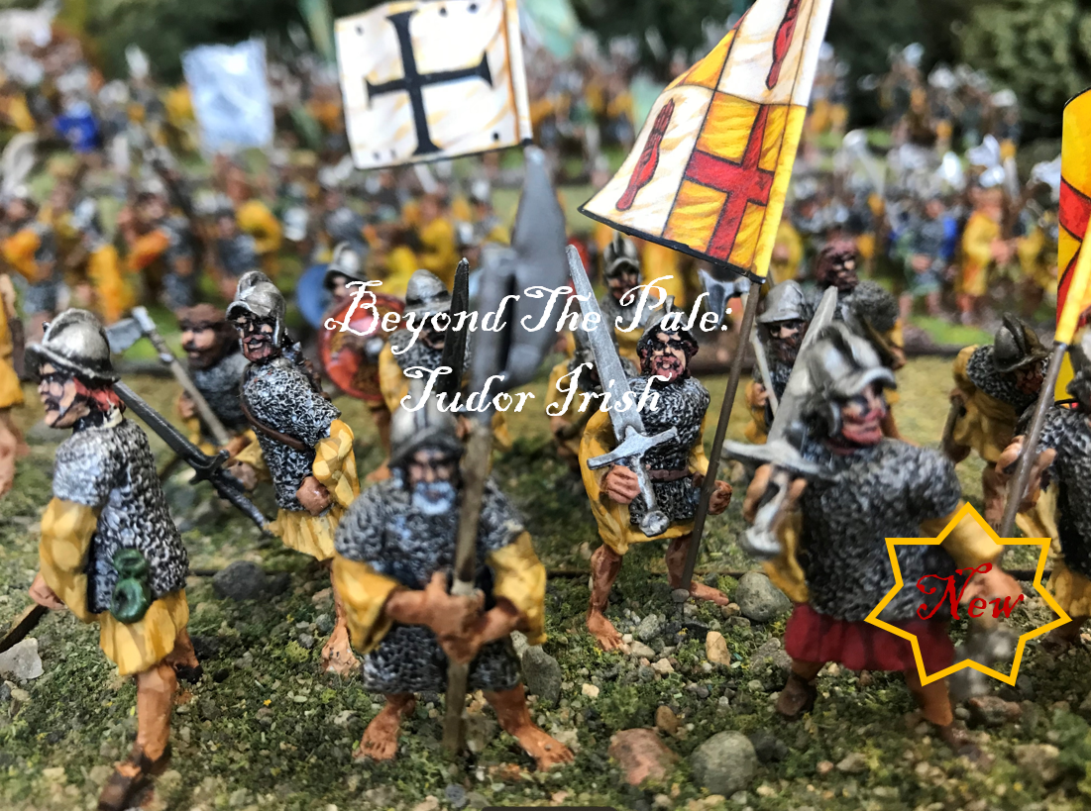

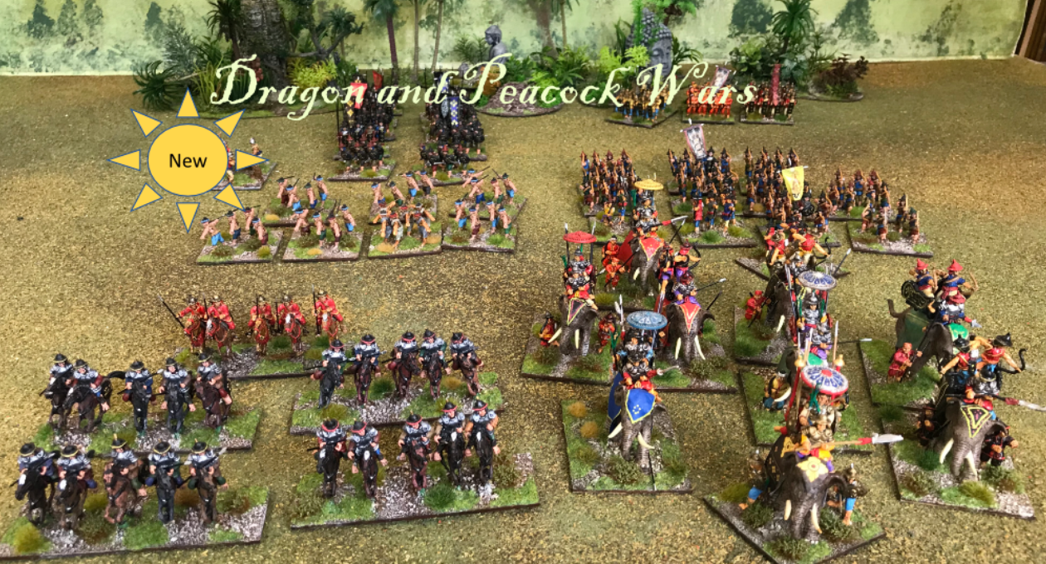
Burmese Army appearing from the jungle.
Contents
Tudor Irish 6
Burmese 7
Qing 9
Korean 11
Mongols 12
Balkan Wars 13
British Colonials 16
German Colonials 18
Spanish Americian War - US 19
North West Frontier - Locals 20
Cuban / Filipino Rebels 22
Mules 23
Renaissance 24
Wargaming Rules 25
Aim 25
An Army 26
Generals 28
Bases 28
Army List 29
Qing 30
Burmese 30
Tudor Irish 31
Tudor Anglo-Irish 31
Quick Reference Guide 32
Sequence of play 34
Extra Kit 35
Fate Pack Outcome 35
Movement and Firing 37
Unit Movement Distances 40
Firing 43
Firing Distances 44
Small Arms 44
Artillery 44
Firing Modifiers 45
Firer’s Firing Modifiers 45
Defender’s Firing Modifiers 46
Melees 48
Morale Modifiers 49
Morale Charge Test 49
Morale Stand Test 50
Many Units charging one 52
Melee Modifiers 52
Deciding the End 53
Scenarios 54
Burmese Capital is under threat 54
Qing have found supplies now must escape 55
Tudor English returning Home 56
Reclaiming your homeland 57
Paint an army in TWO WEEKS 58
Get a copy 64
PDF 64
Paper 64

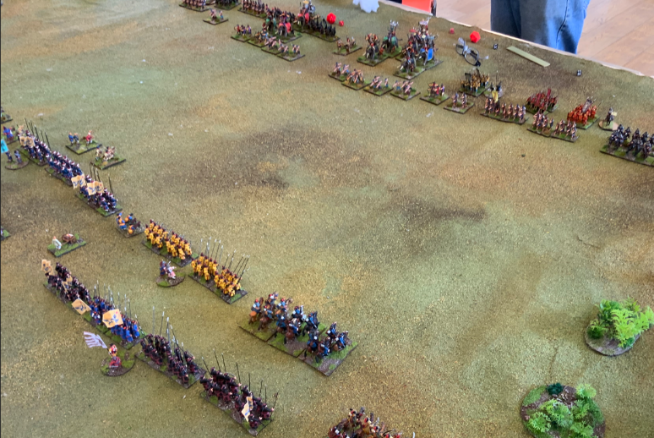

A battle is about to start.

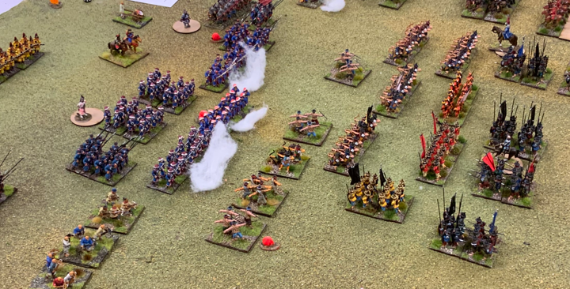
You can use cotton wool to simulate units that have fired.

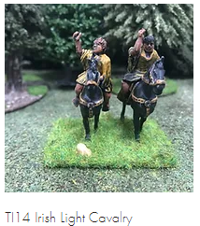
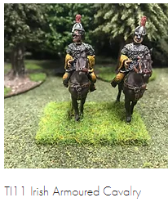
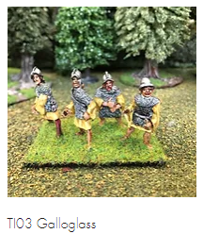
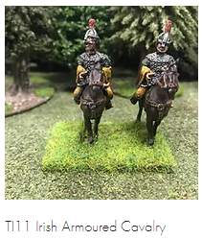
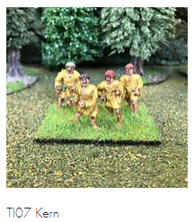
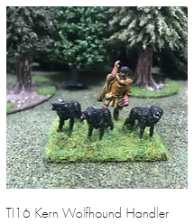
Tudor Irish

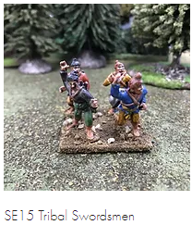
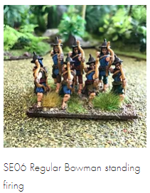
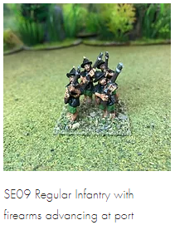
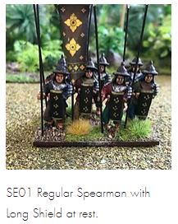
Burmese
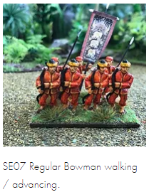

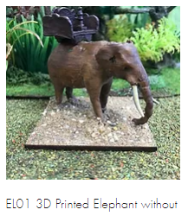
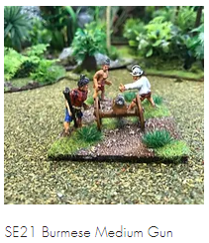
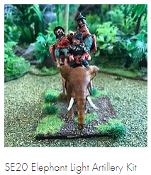
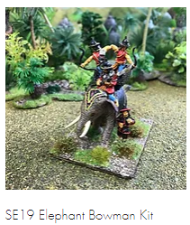
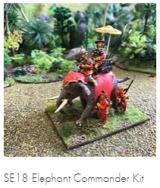
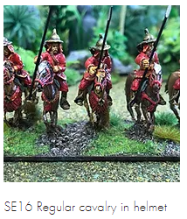

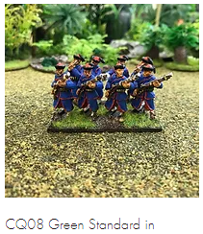
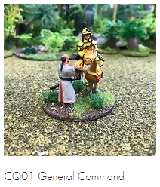
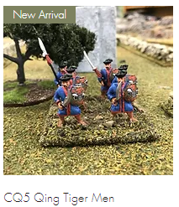
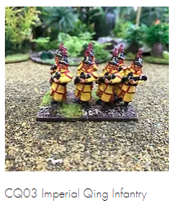
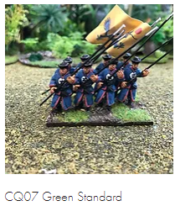
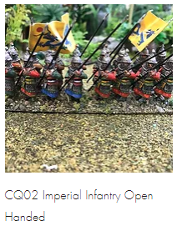
Qing
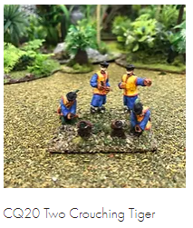
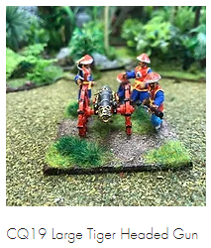
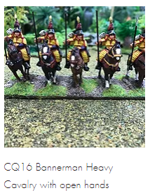
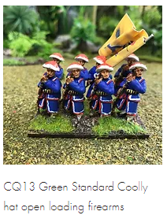
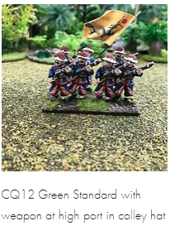
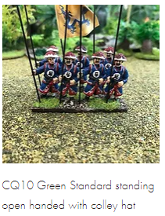

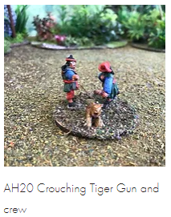
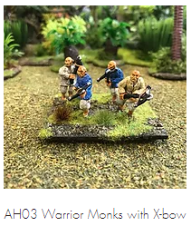
Korean
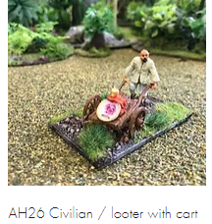
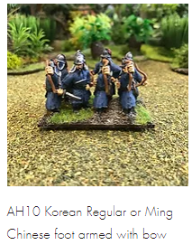
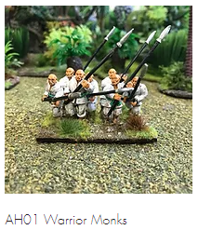

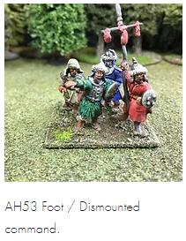
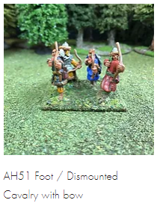
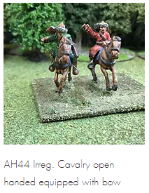
Mongols
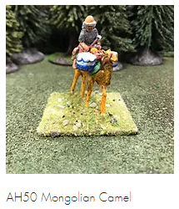
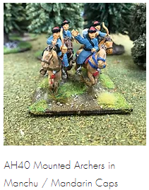

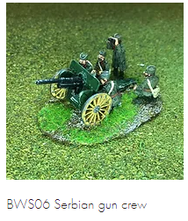
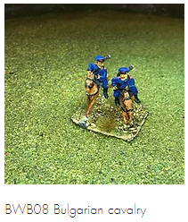
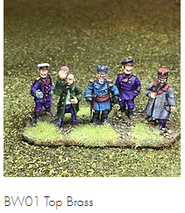
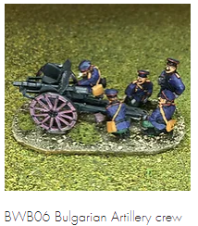
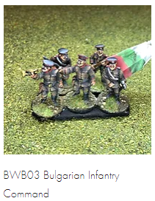
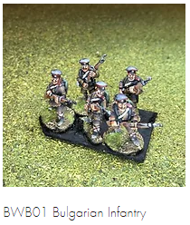
Balkan Wars
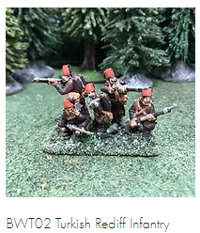
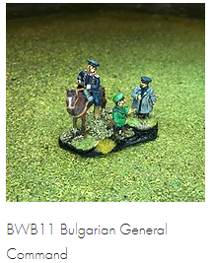
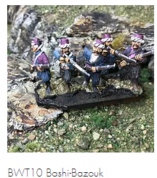
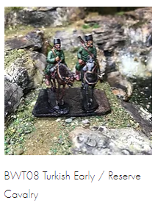
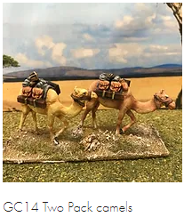
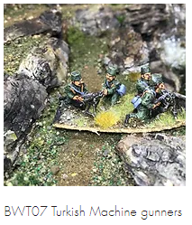

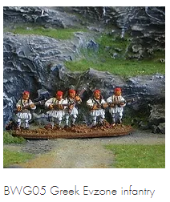
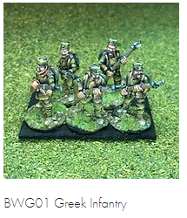
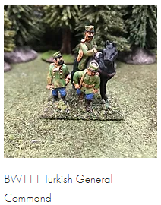
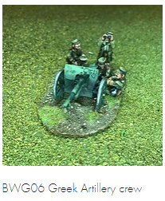
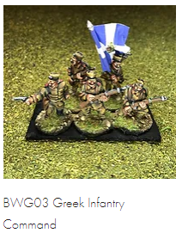

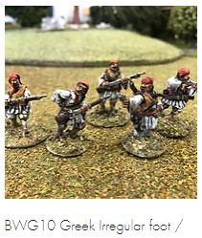

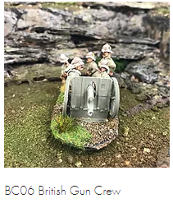
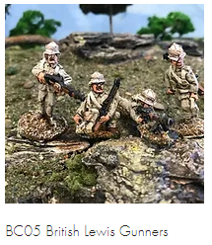
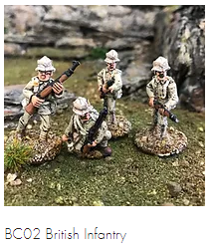
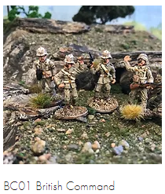
British Colonials
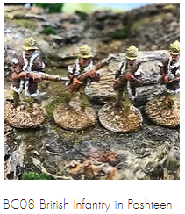
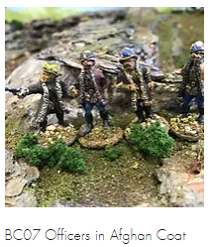
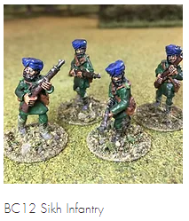
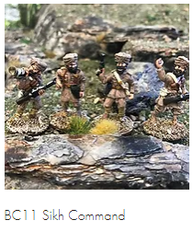
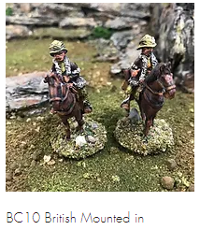
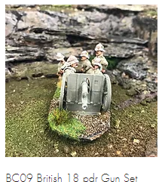
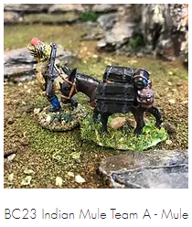
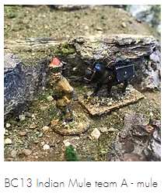

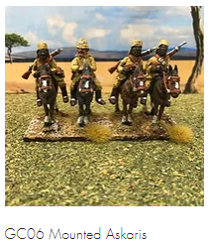
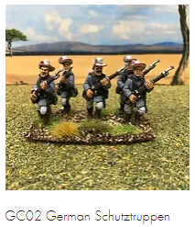
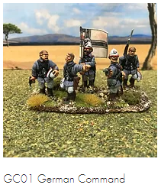
German Colonials
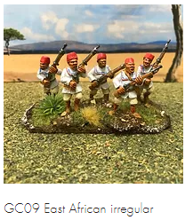
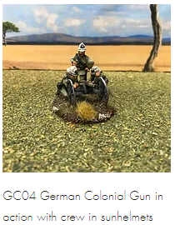

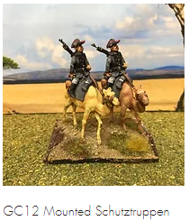

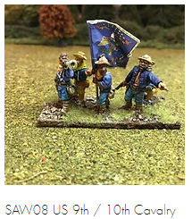
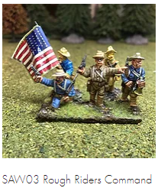
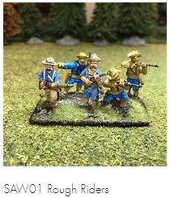
Spanish Americian War - US
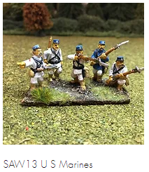
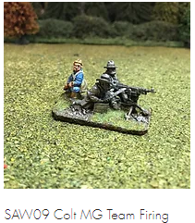
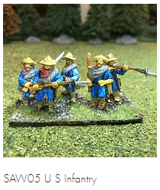

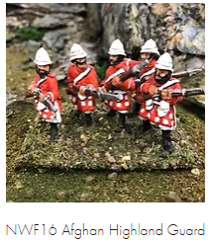
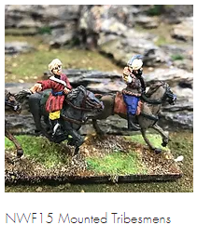
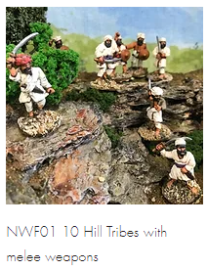
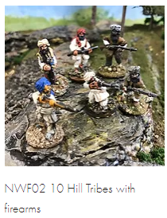
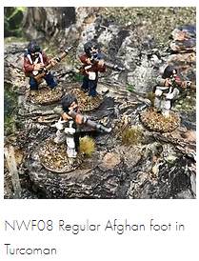
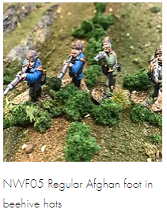
North West Frontier - Locals
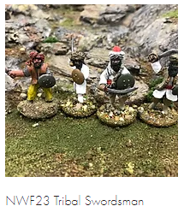
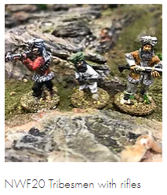
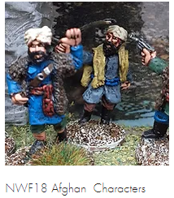
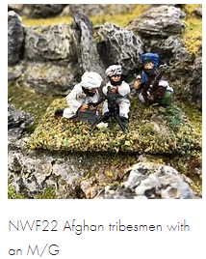
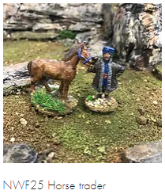
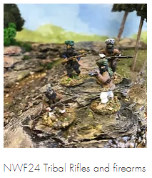

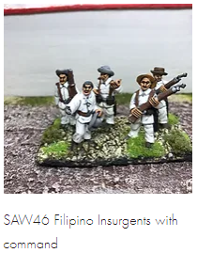
Cuban / Filipino Rebels
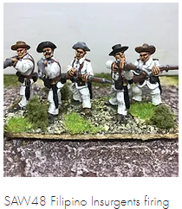
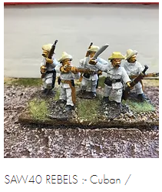
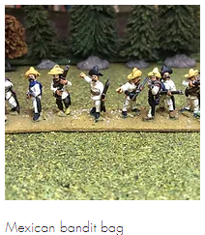
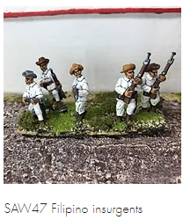

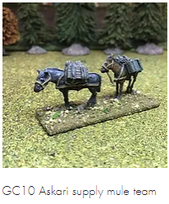
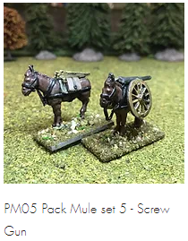
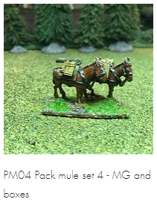
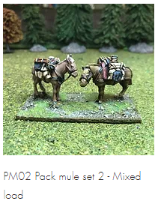
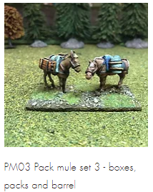
Mules
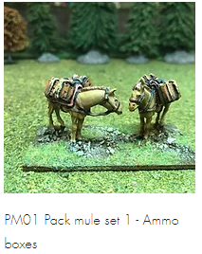

Renaissance

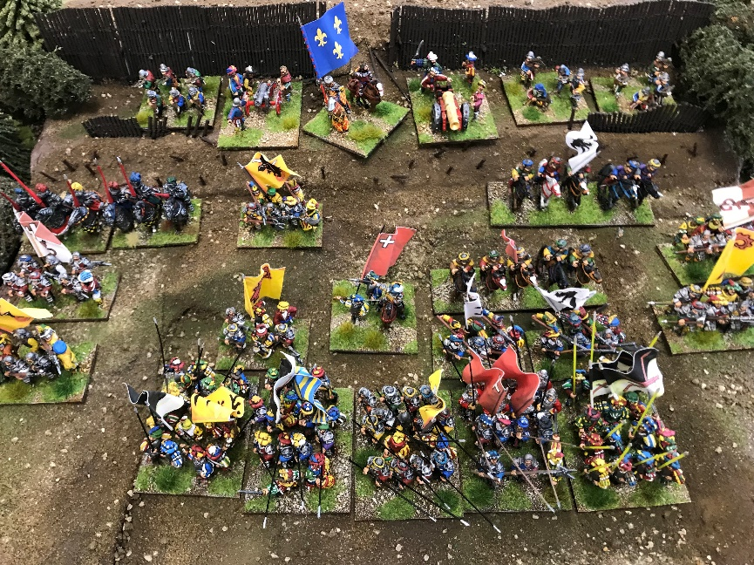
Renaissance Army defending the breach.

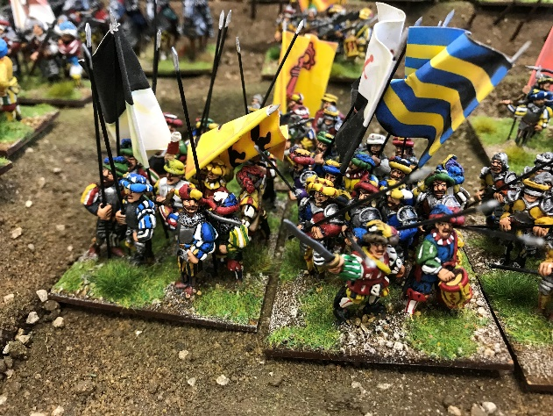

Wargaming Rules

Aim
The aim of these rules is to play a fun, fast, easy to pick up, realistic and action-packed game in less than one to two hours with “large” armies. A “large” army can start with 100 figures per side and grow to four hundred figures plus, with one to two plus players per side. These rules have been played at club level and during the available 4 hours, 2 enjoyable games were played. It has also been used for participation games at trade shows with a range of ages of players and numbers, taking about 1 hour.
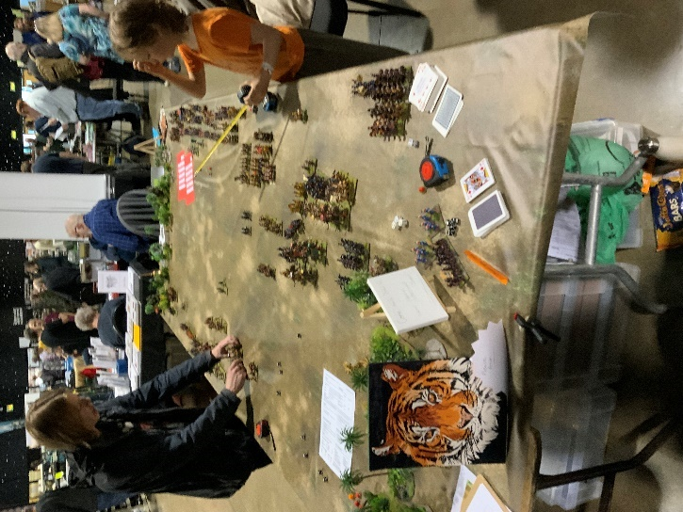
There also comes a point when there is a clear winner, so play can cease and battle reflection take place. The focus is on speed, enjoyment and realism, so that the decisions are reflected in the outcome. Good decisions lead to wins and glory, bad decisions lead to having no troops left and being left wondering “could I do better next time”!
Do I have to rebase all my existing figures to use these rules? No. It allows different base constructions to work successfully together as a unit. If the bases of the two armies are widely different, agree what a unit is for either side; it could be one or two bases to make up a unit to fit in with the opposition, and then remember to use that - which is hard when you are about to charge their line and win yourself “eternal glory”!
What period do these rules cover?
The use of armed groups of men that work as a unit, rather than individuals, across a battlefield, using tactics consisting of massed volleys, from bow to bullet, and charges to win tactical advantage and overcome your enemies.
There is a quick reference guide showing all the details about distances for fire and moment, and modifiers for fire and melees in the centre fold.

An Army
An army is composed of one or more units. A unit is composed or one or more bases. A small unit has only one base. A unit can have more than one type of weapon and selects that weapon at the appropriate time. An army is shown in an army list.
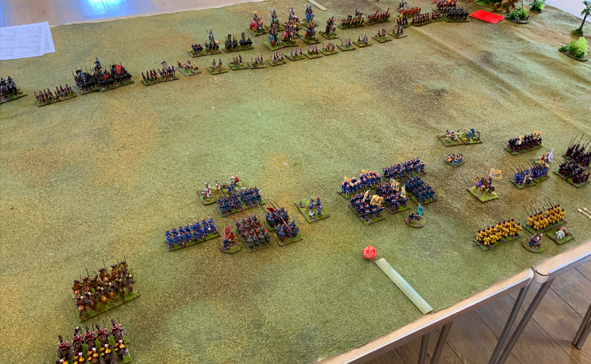
An army list shows what the unit is, how many units you have, what they are armed with, their frontal value, their other value, what can you shoot with and what their unit’s morale is.
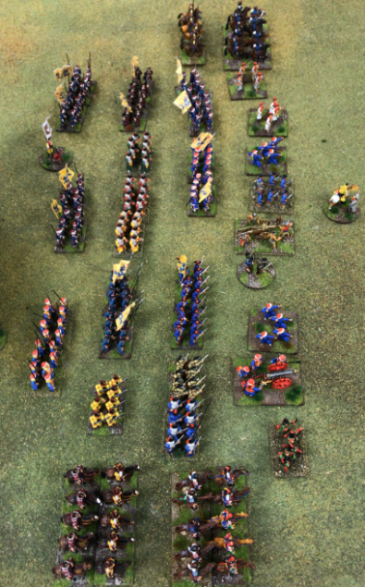
Chinese Qing, at the bottom, vs Burmese.
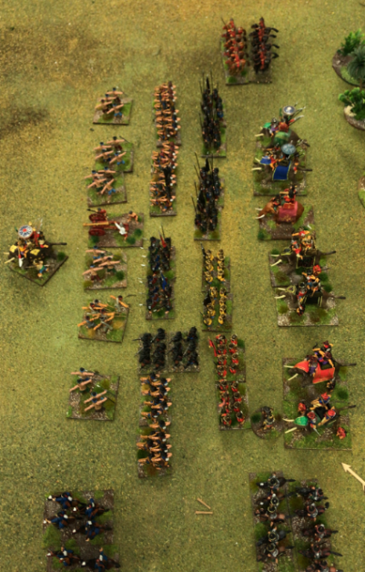

Generals
When deploying your army, it has one General, with a suitable figure or figures. Each van, section or wing also has a Commander figure or figures on a base, for command and control of this wing.
A General can, during the movement phase, attach themselves to a unit, giving that unit improved modifiers. The General cannot attach or unattached to an existing melee. If that unit loses, then the fate of the General resides with that unit. If that unit goes, then the General goes with them unless the General manages to throw a 5 or a 6 on a 1D6. If the General goes then that army has lost. Neither a General nor a Commander cannot be attacked like a normal unit, unless the General is attached.
This commander cannot be killed and represents the commander themselves with his aides and messengers. If a unit goes outside of the command radius of 12 inches, then they cannot move forward, until the commander is in range, representing this group’s command and control.
For participation games, in agreement with all parties (and to keep the momentum of the game), this requirement gets ignored.

Bases
Each unit has one or more bases. Single bases have a deficit on morale tests (minus 1). When you lose, you remove a base from that unit. When all bases have gone, then that unit ceases to exist. A unit fights from its front within a 45-degree arc. There is no penalty for wheeling, just measure the distance from the furthest point of your base to the nearest point of the enemy’s base and move.
But there is no interpenetration of units for regular movement. That means that one unit cannot move through another unit, it has to flow around it. If there are no gaps then it moves along the front until it can move through a gap. If that gap is not big enough, except for skirmishers, it keeps moving along the front.
But if that unit has lost and is running backwards it can flow through another unit. If that unit through which the losers are running has previously agreed to be involved in that unit’s attack and is within 3 inches, to qualify, and the unit in front has lost, then it has to take a morale test. There is nothing like a group of ‘losers’ piling through your unit giving you a bit of a ‘dampener’!

Army List
Frontal (F) and Other (O) Values are used in melee based on the attacking unit’s direction. For example, the attacker can only attack from the front and will use its Frontal Value, but the unit being attacked can be hit on the flank or the rear so use the Other Value.
To determine which side a unit is under attack from, draw a line from corner to the diagonal opposing corner. If the front of the attacking unit is completely within that area, then that is the direction of attack.
? is whether a unit can fire or not.
Dragon and Peacock Wars 1765

Qing
Unit | No | Using | F | O | ? | Morale | Bases
Elephant | 4 | Bow (B) | 5 | 2 | Y | 2 | 1
Elephant | 4 | Spear (S) | 5 | 2 | N | 2 | 1
Foor | 4 | B | 4 | 1 | Y | 2 | 2
Foot | 4 | S | 6 | 1 | N | 3 | 2
Foot | 3 | S/B | 5 | 1 | Y | 2 | 2
Lt Hv Foot | 1 | Sword/S | 4 | 2 | N | 2 | 2
Ditto | 2 | Musket | 4 | 1 | Y | 2 | 2
Skirmish | 7 | Javelin | 3 | 2 | Y | 3 | 1
Skirmish | 4 | B | 2 | 1 | Y | 3 | 1
Hv Cav | 2 | Lance/B | 4 | 0 | Y | 2 | 2
Hv Cav | 1 | Lance/B | 4 | 0 | Y | 3 | 2
Artillery | 1 | Medium | 2 | 0 | Y | 2 | 1
El Art | 2 | Light | 3 | 0 | Y | 2 | 1

Burmese
Unit | No | Using | F | O | ? | Morale | Bases
Hv Cav | 2 | Lance/B | 5 | 0 | Y | 2 | 2
Hv Cav | 2 | Lance/B | 6 | 0 | Y | 2 | 2
Lt Cav | 6 | B | 1 | 0 | Y | 2 | 1
Foot | 8 | Spear | 5 | 1 | N | 2 | 2
Foot | 5 | Arquebus | 4 | 1 | Y | 2 | 2
Foot | 2 | Spear | 6 | 1 | N | 2 | 2
Skirmish | 3 | X-Bow | 2 | 1 | Y | 1 | 1
Skirmish | 4 | B | 2 | 1 | Y | 1 | 1
Lt Hv Foot | 1 | Sword | 4 | 2 | N | 2 | 2
Art | 1 | Medium | 2 | 0 | Y | 2 | 1
Art | 1 | Lt | 2 | 0 | Y | 2 | 1

Tudor Irish
Unit | No | Using | F | O | ? | Morale | Bases
Hv Cav | 2 | Spear | 5 | 1 | N | 2 | 2
Warband | 6 | Axes | 5 | 2 | N | 3 | 2
Warband | 8 | Axes | 4 | 1 | N | 2 | 2
Skirmish | 5 | Javelin | 2 | 0 | Y | 2 | 1
Skirmish | 2 | Bow | 2 | 0 | Y | 1 | 1

Tudor Anglo-Irish
Unit | No | Using | F | O | ? | Morale | Bases
Demi Lance | 1 | Lance | 5 | 1 | N | 3 | 2
Border Horse | 4 | Sword | 4 | 1 | N | 2 | 2
TBP&S | 6 | Pike/St | 4 | 2 | Y | 3 | 2
MP&S | 5 | Pike/St | 3 | 0 | Y | 2 | 2
Militia | 5 | Bill | 3 | 1 | N | 2 | 1
Art | 1 | Medium | 2 | 0 | Y | 2 | 1
TBP&S – Trained Band Pike and Shot; MP&S – Militia Pike and Shot; St – Shot aka Arquebus or Musket based on period.

Quick Reference Guide
Phases  Cards for who goes in firing/moving.  Artillery Simultaneous, no fire & move.  Rally Disordered units use morale. No forward move or fire. Cav must rally.  Move Black and Red cards until all moved. Can move one or more units at once.  Firing Using Cards.  Morale For charging and contact.  Melee In order declared.  Break-throughs  Command Inf radius is 12’’. | Movement  Number of D6. No interpenetration  Infantry Cav  Line 3 5  Column 4  Skirmish 3  Elephant 2  Artillery  Light 2 3  Medium 2 3  Heavy 1 2  Horse Art use Cav.  Evade a Charge 2D6 3D6  Fall back 2D6 4D6  Rout 12 20  Rout becomes  disordered  Breakthro 1D6 2D6  1D6 to do anything else!

Firing  Arquebus 8’’ Bow 24  X-Bow 18 Flintlock 3  Javelins 12 Horse B 18  Horse Jv 8 Musket 10  Pistol 7 Slings 18  Artillery  Type Short Medium Long  Lt 12 15 24  Med 18 27 36  Hv 18 37 56  Firing Modifiers: 1D6 and modifiers. Winner inflicts casualty card turn on looser. | Firing Modifiers  Firer Defender  -1 Disorder +1 Lght cov  -1 Moved +2 Hvy cov  -1 Charged by Cav +1 Skirmish order  -1 Mixed weapons +1 Deployed Artillery  -1 Art Long range -1 Disorder  +1 1/2 range -1 Fire over  +1 Target > 2 base  +1 Target limbered art

Morale Charge Test  1D6 greater or equal to army list morale factor  +2 Charging rear or disordered unit  +1 Charging flank  +1 Charging supported while supported regardless of numbers (not skirmishers)  +1 Attached General  -2 Charging defended linear obstacle or building  -1 One base left  Chargers cannot fire. Fail to arrive do not make contact. | Morale Stand Test  1D6 greater or equal to army list morale factor  +1 Attached General  +1 Defend building/walls etc  +1 Supported by other formed units (not skirmishers)  -1 If left with one base  -1 Disordered  -1 Lost last melee

Melee  A dice shoot off with 1D6 for infantry and 2D6 for cavalry and then these modifiers:  +2 Pike against Cavalry  +1 If enemy disordered  +1 If enemy is Cavalry receiving charge at halt (not moved last go)  +1 Attached General  +1 Supported by one or more formed unit(s): remember the elect rule on supports, if you lose you take a morale test. | +1 Attacking flank or rear  +1 Lance against non-lancers, first go in that melee only  -1 Only has one base  -2 Charging an obstacle  1D6 risk to attached general with saves with 5 or 6.  All cavalry are disordered at the end of a melee

Can ignore this: If out of van general’s command radius a unit can’t advance to enemy but may retire or turn about to face.
General can only attach/detach except if unit in melee. Remove smoke.
Cav command themselves.

Sequence of play
What is the sequence of play? There are the following phases:
# | Phase | Comment
 | Artillery | If this artillery unit fires it cannot then move in the next phase. Using the Fire Mechanism below; Destroyed base cannot return fire.
 | Rally | Disordered units can try and rally. If the unit remains disordered it cannot move forward nor fire, though it can retire, and if it is charged it can fight, though with a disadvantage.
 | Move | Use the card mechanism below.
 | Firing | Use the card mechanism below.
 | Morale | For Charging and then Charged units.
 | Melee | In order declared during the movement phase.
 | Breakthroughs | For melee victors.

Extra Kit
What extra kit apart from figures and scenery do I require?
- One or more D6 dice with 1 to 6 on each side;
- Melee Marker – perhaps an arrow, or a tiger pointing in the direction of the attacker. It is helpful to remember the order in which the melees take place, for after all the moment and firing is done, then melees take place in that order.
- Disordered Markers – perhaps a skull or something similar;
- Movement Card Pack – normal card pack but without Jacks, Queens, Kings and Jokers;
- Fate Cards for Firing or Melee Results - normal card pack but without Jacks, Queens, Kings and Jokers, with each suit representing an outcome for the loser, see below.

Fate Pack Outcome
Suits | Action to Loser
Hearts | Kill – remove a base from a unit, and if that is the last base, remove that.
Diamonds | Disordered – apply a disordered marker to that unit.
Spades | Nothing happens.
Clubs | Fall Back – see Movement Table below and apply that number of inches. The unit is then disordered or it may have left the field. The direction of fall back is in the direction of the charge and away from the enemy. Unit or units flow around those behind them.

Tiger Miniatures has
- Movement arrows in an STL file for melees
- Skulls in a STL file for disordered markers

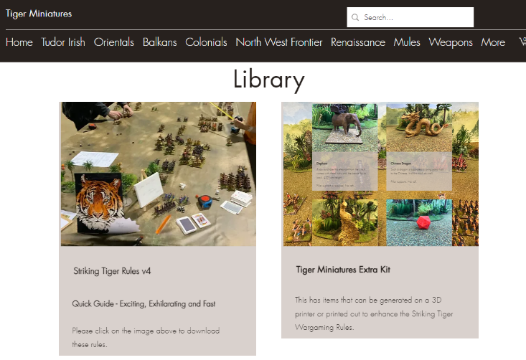
All of these can be found at
https://www.tigerminiatures.co.uk/library

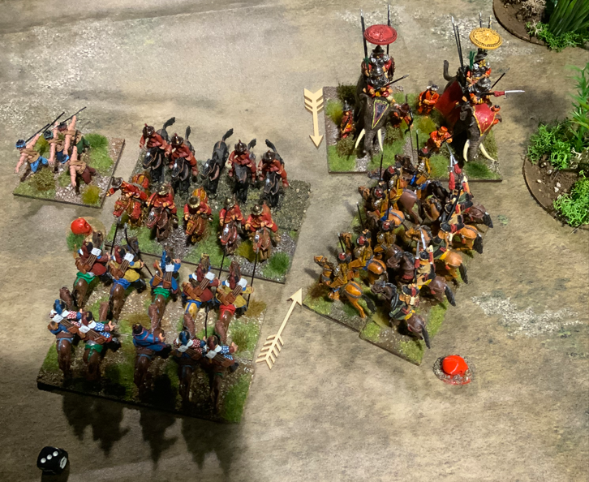
Arrows showing direction of attack and red skull that this unit is disorganised.

Movement and Firing
Movement is completed for both sides and then firing is completed on both sides, followed by morale tests for melees and then melees, if there are any.
Both movement and firing use the card mechanism. It is suggested that you have one pack of cards for Movement and another, suitably labelled, for the Fate Outcome. At the start, each side agrees whether they are a red or black team, denoted by the red or black suits.
Either the umpire or a player is nominated or each player can take it in turns to draw a card from the Movement Card Deck, and the team with that colour has been given the opportunity to move.
It is easiest to put the drawn card in a pile by the side of the Card Decks. When the Card Deck is empty, reshuffle the drawn cards and continue.
If your team wins you decide what unit or units to move. You can only move a unit or units in one direction and then your movement is complete for that unit or units and you have to wait for your colour of Movement Card to turn up again to move other units in a different direction. You have to move, or, if you prefer, you can assign a non-movement to a unit or units to see what the enemy are doing, but that unit or units cannot then move this turn. If you pass then it is considered that you have moved all your units.
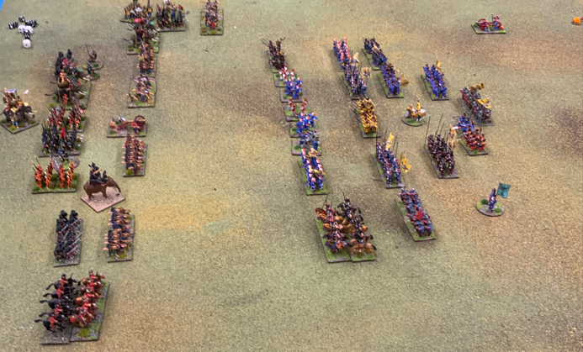
Qing Army on the right advances.
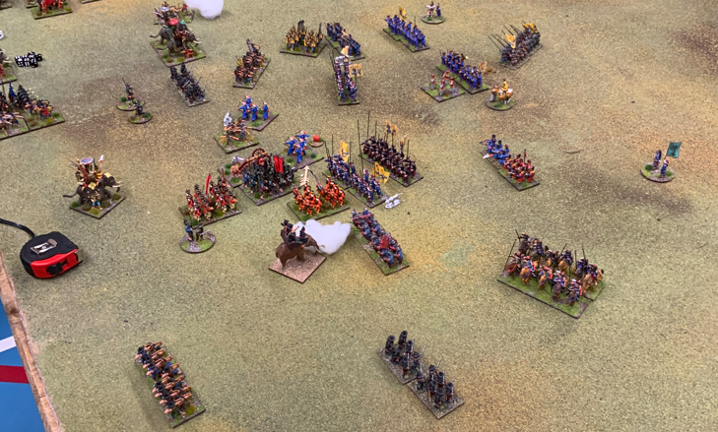
Has the attack stalled?
When playing more than one player per side, each commander on the side that has won the movement, has the opportunity to move.
You keep drawing cards until all units on all sides that want to move, have moved.
A short cut for this is that if one side has moved all their units then the other side can complete their movement without drawing any more cards.
A movement can be a charge into any part of the enemy’s unit. When this happens place a melee marker to show who is charging and in what order these charges will be resolved once all the movement and firing has finished. Do not move the unit completely into contact but leave a space of 1 to 3 inches between the two opposing units.
This is because you may not manage to get into the melee, either due to failing a morale test or that unit becomes disordered or is killed due to the enemy’s fire.
You notify the enemy’s commander saying that you want to move this unit or units to this location, pointing to that location, or you can say that you want this unit or units to go as far as possible in a certain direction and then you throw a 1D6 and multiply that number type (infantry or cavalry) against the unit’s movement distance below. The result is the distance, in inches, that unit or units can move.

Unit Movement Distances
Unit | Infantry | Cavalry | Comment
Line | 3 | 5 | 1D6 and multiple by this value.  Line is where the unit has its bases one beside the other.
Column | 4 |  | This is where a unit has its bases one behind another.
Skirmish | 4 |  | Only units that have been designated as skirmishers.
Elephant | 2
Artillery | 2 | 3 | Light or Medium
Artillery | 1 | 2 | Heavy
Evade | 2D6 | 3D6
Fall Back | 1D6 | 2D6 | This can happen when you lose a melee and the Melee Card says Fall Back.
Rout | 12 | 20 | A Defending unit in a charge fails its morale test and goes back this distance and is disordered.
Break-through | 1D6 | 2D6
As a result of winning a melee the winner can elect to do a break through and continue their success. If they meet the enemy again the fight continues, until it is concluded, which may involve another breakthrough!
It costs the use of 1D6 to: back step, side step, limber/unlimber, change formation, form square, move through woods, fordable water or rough terrain, crossing obstacles, and walls etc. All can move through woods except artillery and wagons.
For wagons think light artillery.
Cavalry also covers artillery pulled by horses.
This mechanism means that the unit or units you commanded to move may not reach the point where you wanted them to be. For example, the distance to the enemy is 13 inches and you ordered three infantry units to move up and engage them. You, as the commander, after notifying the enemy’s commander of your intention, throw a 1 on the D6, so those three units can only go their movement’s distance which, as you are in line, is 3 inches.
Or that unit got a very high score but will ONLY move the location that you ordered them. On the other hand, if you are a cavalry commander say to one or more cavalry units, go as far as they can and you get a 6, then that unit or units will move 30 inches, which could take them far away from where you wanted them to be or even off the table.
Any unit or units that move off the table are deemed lost.
With this mechanism, you could say at the start of the game, all the army, except the artillery, are to move as far as possible forward. All your units to start with are, say, in column and you throw a 6, lucky you, and so all the units will move 24 inches, since you are moving at the rate of the slowest unit.

Firing
When all eligible units have moved, then those units that are in range can fire (see Firing Distance Table below). Artillery, if present, have already fired at the start of the move and used the same mechanism. If you have forgotten to fire the artillery, then that is unfortunate, so you need to remember next time. And don’t forget to fire artillery on the elephants or other animals too.
Infantry fire at their closest enemy. Artillery can select not obscured targets. The Firer cannot fire into an existing melee. A charging unit cannot fire.
Firing is based on the type of weapon a unit carries. If a unit carries multiple weapons, then you select the type of weapon you would like that unit to use.
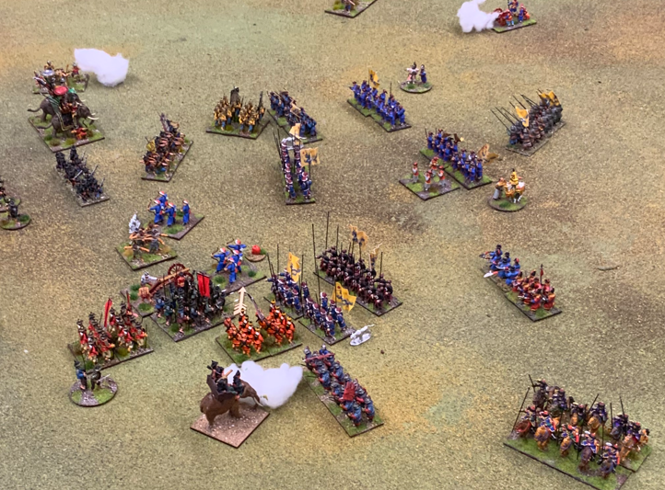

Firing Distances

Small Arms
Small Arms | Range  in inches
Arquebus | 8
Bow | 24
Crossbow | 18
Flintlock | 3
Javelins | 12
Mounted Bow | 18
Mounted Javelin | 8
Musket | 10
Pistol | 7
Rifle | 30
Slings | 18

Artillery
Type | Short | Medium | Long
Light | 12 | 15 | 24
Medium | 18 | 27 | 36
Heavy | 18 | 37 | 56
This say short distance is from the muzzle to 12 inches.
The Movement Card Deck has now become the Firing Card Deck and the team that wins that colour, fires all their eligible units. This is a dice off between the unit firing, known as the Firer, and the unit receiving the fire, known as the Defender, with their firing modifiers applied.

Firing Modifiers

Firer’s Firing Modifiers
Value | Status | Comment
-1 | Firer is disordered
-1 | Firer has moved
-1 | Firer is being Charged by Cavalry
-1 | The target is in the long range | This is for artillery and the distance is between medium and long-range range.
+1 | The target is within short range | This is for artillery where the target is in short range and for units that are within half (1/2) their small arms fire range to represent more hits as the target is closer.  A Firer firing at a charging unit may have this modifier, even if the unit started outside their half way range.
+1 | The target is more than two bases deep | The target has more than two bases behind the front base. This is a unit in column or just a very large unit.
+1 | The target is limbered artillery | The target is artillery being pulled by horse. A rather fat and large target.

Defender’s Firing Modifiers
Value | Status | Comment
+1 | In light cover | Light cover is scrub, woods, behind fences or hedges.
+2 | In heavy cover | This unit is in a building or behind prepared defenses.
+1 | In skirmish order | These figures in the base that makes up the unit are dispersed.
+1 | Deployed Artillery | Similar to skirmishers, this unit is more difficult to hit.
-1 | Disordered
-1 | Firing overhead | Firer cannot see the target.
The Firer selects the target unit and throws a D6 and applies any modifiers. Artillery can select any unit to its front within a 45-degree arc that they can see and are not obscured. If they want to fire at another unit outside the 45-degree arc they need to move and wait for the next go.
If the Firer is artillery or bow on elephants they can fire over the units in their front as long as those units are within half their firing range.
Other Firer units must select the nearest units within their 45-degree arc. Units with bow can fire overhead as long as their troops are within half their range. As these troops cannot see there is a modifier.
If the Firer gets a one, then nothing happens.
If the Firer gets more than one, then the Defender throws a D6 and applies any modifiers to produce a total value. If the Defender loses then that unit selects a Fate Card to determine what happens to them. If the score is the same or greater than the Firer then nothing happens.
If the unit is disordered put a disorder marker next to it. If the unit was charging, then leave that unit where it is, as it cannot make contact and so no melee takes place, as this shows the unit attempting to reach their enemy but not making it.
If the loser’s base is “killed” and they are eligible to fire, then either turn the front base around and resolve the firing later or resolve their firing results straight away and then remove that base.
If the Defender is fired on again by another unit repeat this process.

Melees
Do the melees in the order that they occur as their result may affect subsequent events.
If a unit is in a melee, then three things happen:
- The Charging unit takes a morale test;
- If the Charging unit passes, the Defender unit takes a morale test;
- If the Defender unit passes, then the melee takes place.
If the Charging unit fails their morale test, move them back to where they started, or if you cannot remember, back to where you think they started, not forgetting their disordered marker, if they have one.
If the Defender unit fails their morale test, then that unit routs, moving back the distance as shown on the Unit Movement Distances Table. This can result in this unit leaving the table.
To take a morale test:
- Find that unit’s morale value from their Army List;
- Work out their modifier value: if they are the Charging Unit use the Morale Charge Test Modifiers Table and if they are the Defender Unit use the Morale Stand Test Modifiers Table. This could be a negative value;
- Add this to the unit’s morale value to produce a modifier value;
- Throw one D6;
- If the D6 value is the same or greater than the modifier value then that unit has survived their morale test;
For example, a disordered infantry unit with a morale value of 2, that lost its last melee, but is supported by other units, and is being charged by another infantry unit. Look in the Morale Stand Test Modifiers and see that it has +1 for support, -1 for disordered and -1 for lost last melee, making a modifier value of -1. The unit then throws a 1 on a D6 and so gets -1 + 1 = 0 and fails its morale test.

Morale Modifiers

Morale Charge Test
Take this test is you are about to charge another unit. Note that a disordered unit cannot fire or move forward, so it cannot charge, though it can be charged.
Value | Status | Comment
+2 | Charging rear or disordered unit
+1 | Charging flank | If all of the front of the attackers are on the flank – see above what a flank is.
+1 | Charging while supported regardless of numbers supporting (not skirmishers) | A unit can, withing 3 inches, elect to support another unit’s attack. If they do and the attack fails then this unit must take a morale test.
+1 | Attached General | This is the Army’s General and not the commanders. A General must have joined before the attack and cannot leave until the attack is over.
-2 | Your unit is charging a defended linear obstacle or a building | It’s just hard.
-1 | Your unit is a small unit | A small unit is just one base.

Morale Stand Test
Value | Status | Comment
+1 | Attached General | Nowt like having the boss around to help with the morale.
+1 | Defending buildings or walls | Basically, hard cover. Soft cover has no effect here but can when being fired upon.
+1 | If supported by a formed unit (not skirmishers) | It doesn’t matter how many, this only counts once, but they need to be within 3 inches. It’s like someone has your back.
-1 | Only have one base left | If the unit started out with two or more bases.
-1 | You are disordered
-1 | Lost the last melee | Your unit is suffering so perhaps it cannot stand.

The Charging and the Defender unit do the following
- Take their Frontal Value or in the case of the Defender Unit not being attacked at the front their Other Value from their Army List;
- Work out a modifier value based on the Melee Modifiers below (not the Morale Modifiers), this could come out negative;
- Throw one D6 for infantry and two (2) D6 for cavalry;
- Add this to the Value to produce a Total Score;
- If both of these scores are the same nothing happens to the units, they continue the melee into the next round, otherwise the unit with the lowest score takes a Fate Card;

Many Units charging one
If a Defender is charged by more than one unit then they keep the total value they had from the previous melee and use it in the next melee.

Melee Modifiers
Value | Status | Comment
+2 | Pike against Cavalry | Horses really don’t like pikes.
+1 | If the enemy unit is disordered
+1 | If the enemy unit is Cavalry receiving the charge at the halt (not moved last go) | Since during the movement phase you managed to ‘catch’ the enemy’s cavalry there is a bonus for this.
+1 | Attached General | Fortune favours the brave.  This is the Army’s General not the van’s commander. The unit needs to do their better than best now. But it is double edged.
+1 | Supported by one or more formed unit(s). | A unit can elect to support and be within 3’’. If the unit it supports loses this unit must take a morale test.
+1 | Attacking an enemy’s flank or rear
+1 | Lance against non-lance | You have lance but your enemy does not. Can only be used in the first round of each melee, as a lance tends to be difficult to use for a longer time.
-1 | Small Unit | One base. You just don’t have the numbers with you, but you’re courageous.
-2 | Charging a defended linear obstacle or into a building | Again, it’s just hard.  But your unit may have the frontal value for this!

Deciding the End
As the battle progresses, one side will appear to be making better gains in terms of area won and enemy units removed from the battlefield. It slowly becomes obvious that one side has the upper hand and that the other, despite their best endeavours and luck, cannot change this tide. At this point, with all the participants’ agreement, another one or two rounds can be played to see the extent of the success or to what extent the tide can be turned; alternatively, time can be called, with handshakes and congratulations all round. The winners will remember the how, the losers can consider the ‘what we could do better next time’!

Scenarios

Burmese Capital is under threat
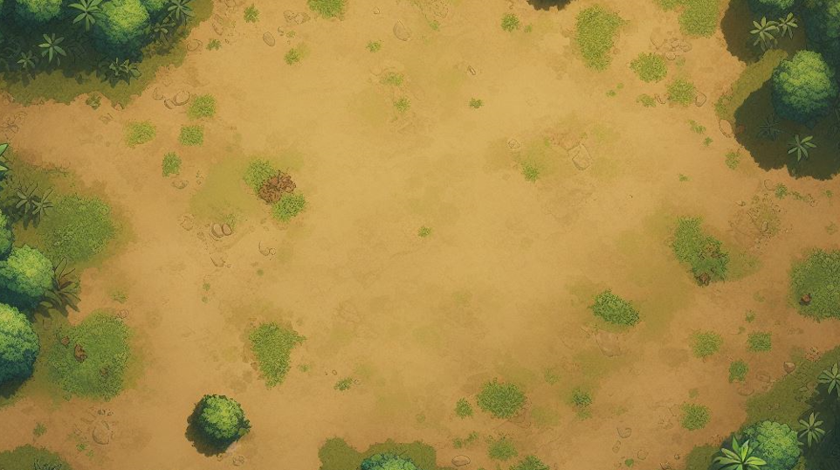
The Chinese Qing, despite all the Burmese best efforts are now within a week’s march of their capital. The Burmese deploy first, and await the arrival of their enemy.
Qing arrives at the top.
Burmese arrives at the bottom.
Use the Qing and Burmese Army list.
Qing Victory – push through to the capital.
Burmese Victory – Qing are stopped and pushed off the field.

Qing have found supplies now must escape
A village deep in the jungle has been raided by the Qing and now the need to escape with the spoils.
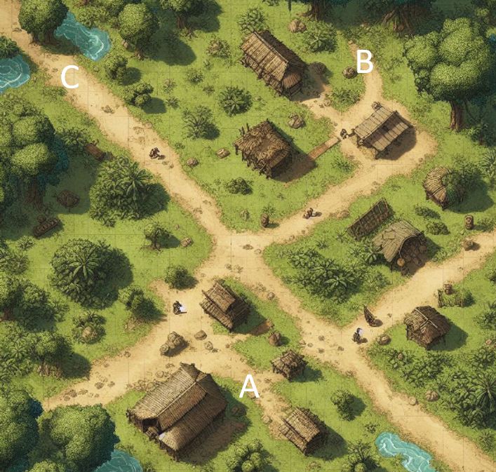
A: Qing with 4 foot, 2 light cav plus mules.
B: Burmese arrive with 3 foot, and 4 light cav.
C: Qing need to exit here with the mules.
Qing Victory – Leave with all mules.
Qing Defeat – Leave with none.

Tudor English returning Home
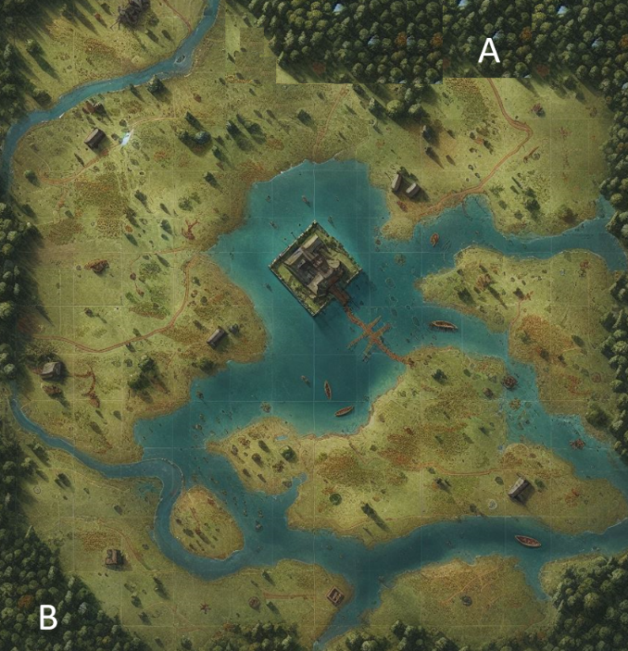
The English are returning home to their fort in the bog with long awaited supplies from over the seas.

A: English arrive and need to get to the fort
B: Tudor Irish warband arrives to stop them
All water except around the fort can be crossed. English need to use the bridge.
Use Tudor Irish Army list, plus a number of wagons for the English.
English Victory – Get their supplies to the fort.
Irish Victory – Get the English supplies.

Reclaiming your homeland

You have successfully pushed the Qing out yet a small force remains in a deserted temple complex.
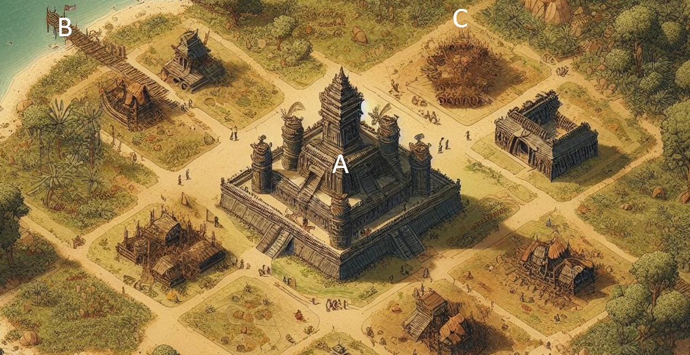
A: Qing is in this temple resting up and does not appear until the first Burmese troops arrive.
6 foot and 1 light Cav.
B: Boats will arrive in turn 5 to rescue the Qing.
C: Burmese arrive here. They must do movements to arrive down the road.
4 foot, 2 light cav, 1 heavy cav, two elephants one with light artillery.
Qing Victory – if any of their troops take to the boats.
Burmese Victory – if they stop the Qing and take back their temple.

Paint an army in TWO WEEKS
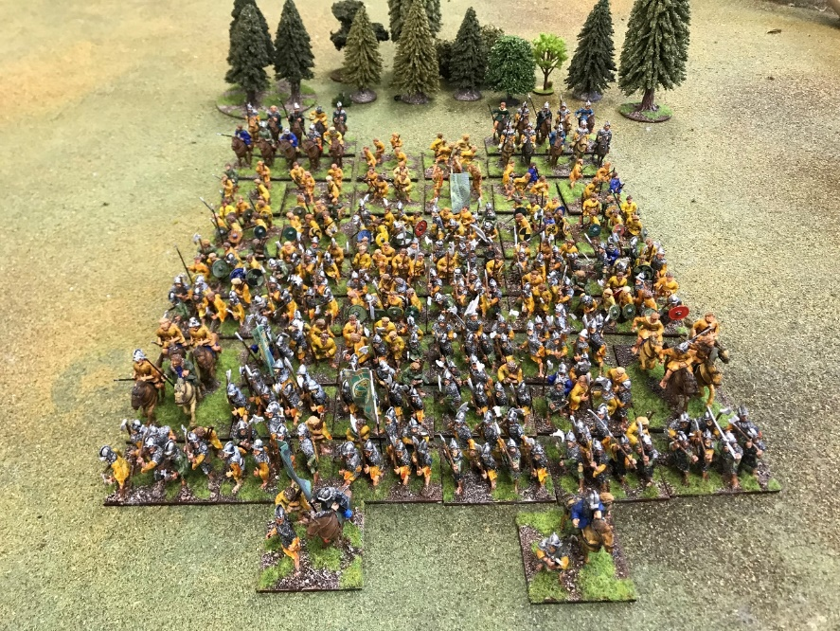
286 figures from Tiger Miniatures Tudor Irish Range
Yes, that’s right, you can paint this army in two weeks and have them ready for battle. Magic aside, it’s about keeping up the cadence with the end result in mind. It’s only a few hours every day for two weeks. We spend that time watching TV each day, so you could do both!
The key to this is to remember that at the distance you are moving these wonderful figures around the battle field, what can you see? Certainly not the eyes, nor the wonderful painted expression on their faces, nor the blotch where you put more paint than intended, for it’s the overall effect that you are after.
So, Pete of Tiger Miniatures, who sculpted and painted this army, says:
“Tongue depressors, start with tongue depressors. They are cheap and strong. Using double sided sticky tape, stick similar figures on the depressor, so that when you paint you can repeat one motion quickly over all these four or five figures. You shouldn’t have to do much work to prepare them either, just snip off a small piece of pewter or file down a base or two to make them easier to stick to the depressor.
Then, spray paint them with matt white.
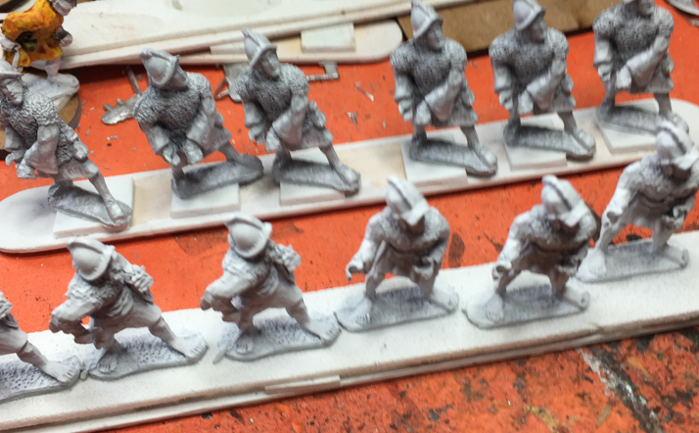
It’s best to do this outside. Spread them out on a piece of cardboard, so you can carry them and spray them in groups. Wearing plastic gloves saves much hand cleaning afterwards! Leaving them outside to dry means you don’t pong the house out, but remember to keep an eye on the weather!
Next, I paint all the flesh. Don’t worry if this goes over other areas.
Then I paint the armour silver with an armour wash by Colour Party Paints, but others companies make this too. Just splash it on and keep going.
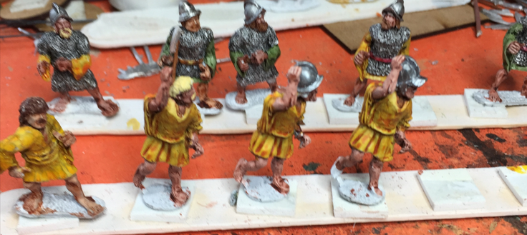
I have two yellow contrast paints for their clothes. On one depressor strip, I paint in one colour and the other in a contrast, to provide some variance.
Bags and belts and shields I paint with ‘normal’ paint, light or dark brown as I go. Don’t worry about painting over what you have already painted, unless your nervous twitch really does splodge the figure.
I paint the weapons separately. For axes, a brown for the shaft and normal silver paint for the axe head. For the spears, I cut the black fletchings off the brush head and super-glue them to the spear carriers, trying not to glue myself to the figures as I go! Then I dab some silver paint on the top to represent the pointy, sharp end.
Shields tend to be fiddly. Dab glue on both parts for those figures on the tongue depressor and then fix them on. Remember, for most figures you aren’t going to see the inside of the shield. Then use browns and silver on the facings.
Standards, that’s the final hop. I print suitable images out from the Internet and cut and glue them to the same black fletchings I use for the spears. When the glue is drying, I crinkle the flag to make it appear the wind has captured it. For this army there aren’t that many!
The final challenge is basing my army. Tiger’s figures come in groups that I like. I base according to Armati rules, that is they have defined base sizes and defined numbers of figures per base; I’ve worked out the number of bases that I need during this process. To give added heft, a friend of mine bases on steel, as these bases aren’t as high. After all, we try to pick the figure up by the base but do often end up picking up the figures!
These next steps seem ‘tedious’, but are simple and provide a great effect:
Position the figures on the base and then stick them in place with UHU glue. When dry, put PVA glue over the top of the base, and put them into a compound comprising of budgie sand and grit (the more grit the rougher the result) and leave to dry.
Using a brown wash, basically watered down brown, quickly go over each base. Don’t worry if you splodge the figure. That’s the mud that is an army’s constant ‘friend’ or ‘menace’.
Once you have brown-washed the bases, made from cheap pen ink and a bit of water, where you started first will be dry, so, using a magnolia or similar off-white from a paint tester can, dry brush this base. You should have a very little amount of white on this brush so that if you accidently ‘hit’ the figure, the damage will be very limited.
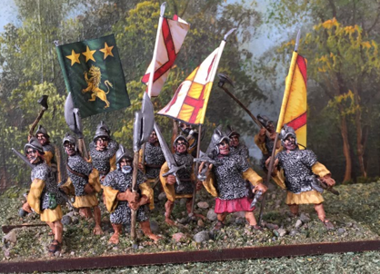
Lastly, I put PVA glue over a few areas of each base and then dunk in a flock bath to give a patchy, grassy effect.
Overall, for these two weeks, I’d say that the first few days is preparation work. That is putting the figures onto the depressors and spray painting them.
Then, about 9 days is splashing the paint around. Don’t worry if, as you go along, you feel that the results look ghastly. It will all come together in the end.
The final few days is basing. Obviously, your times will vary, but remember, don’t dwell on one process, just ‘crash’ on. And if this is starting to take you too long, think about why, and if you can try and remedy it.
My major challenge is not actually doing this work; its warding off the call ‘Pete can you come here and do this, or that’, during the few hours a day I give myself.
Just give it a go. Say to yourself “I’m turning ‘lead’ into ‘gold’!”
The joy I have now, is pushing this wonderful army around their battlefield. Whether they win or lose, well, that’s not the point. It’s having them, having a go.
Enjoy.
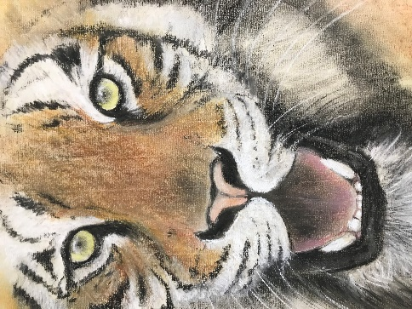

Tiger, tiger, burning bright..

Get a copy

PDF
You can find a PDF version of this booklet on
www.tigerminiatures.co.uk/library

Paper
You can order a paper copy from
https://www.tigerminiatures.co.uk/burmese?page=2

Copyright Tiger Miniatures
This book has been produced by Charles Huthwaite of Tiger Miniatures October 2023 (v4).

Printed by:
Bromsgrove Printing
sales@bromsgroveprinting.co.uk
14 Worcester Road
Bromsgrove
01527 873181

“May your dice rolls be forever 6’s, well most of the time!”

